Program 4 Report

By: Mohammed Mohiuddin

# Location of Website and Object

Here is the location URL of my website

<https://css436program420240228172706.azurewebsites.net/>

Here is the location URL of my input.txt file in blob storage

<https://mohammedstorage1234.blob.core.windows.net/mohammedcontainer1/input.txt>

* Initially, this used to download as soon as you viewed the link, but I was able to change the content type to plain/text so it can be viewed instead of downloaded.

# Design Diagrams

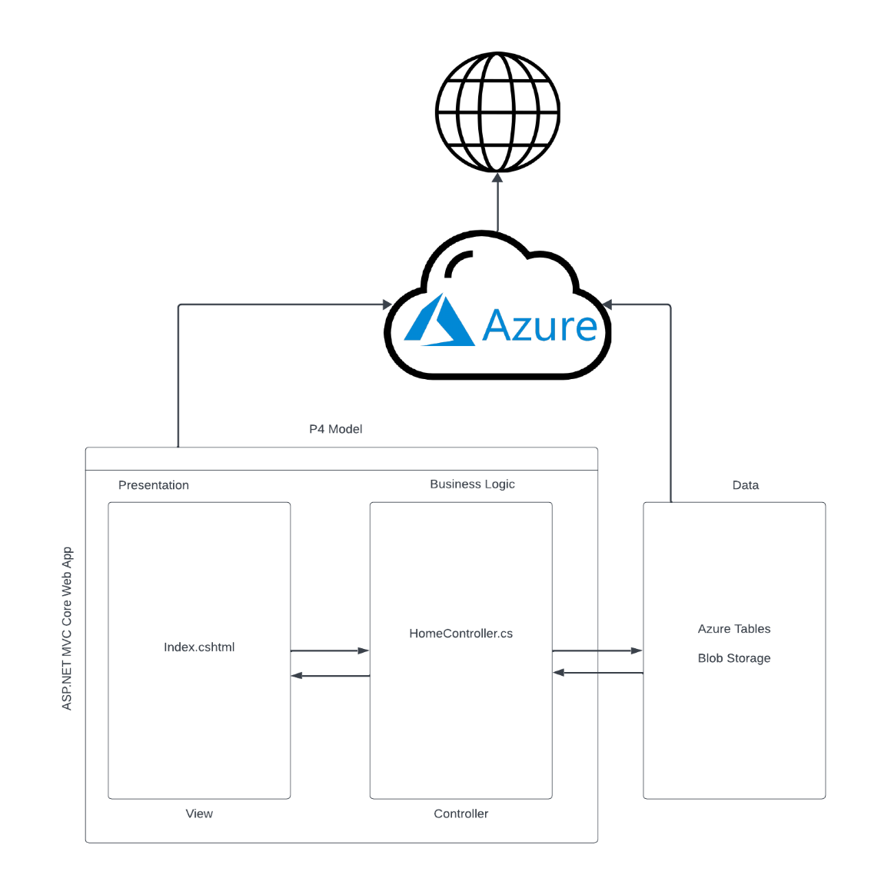

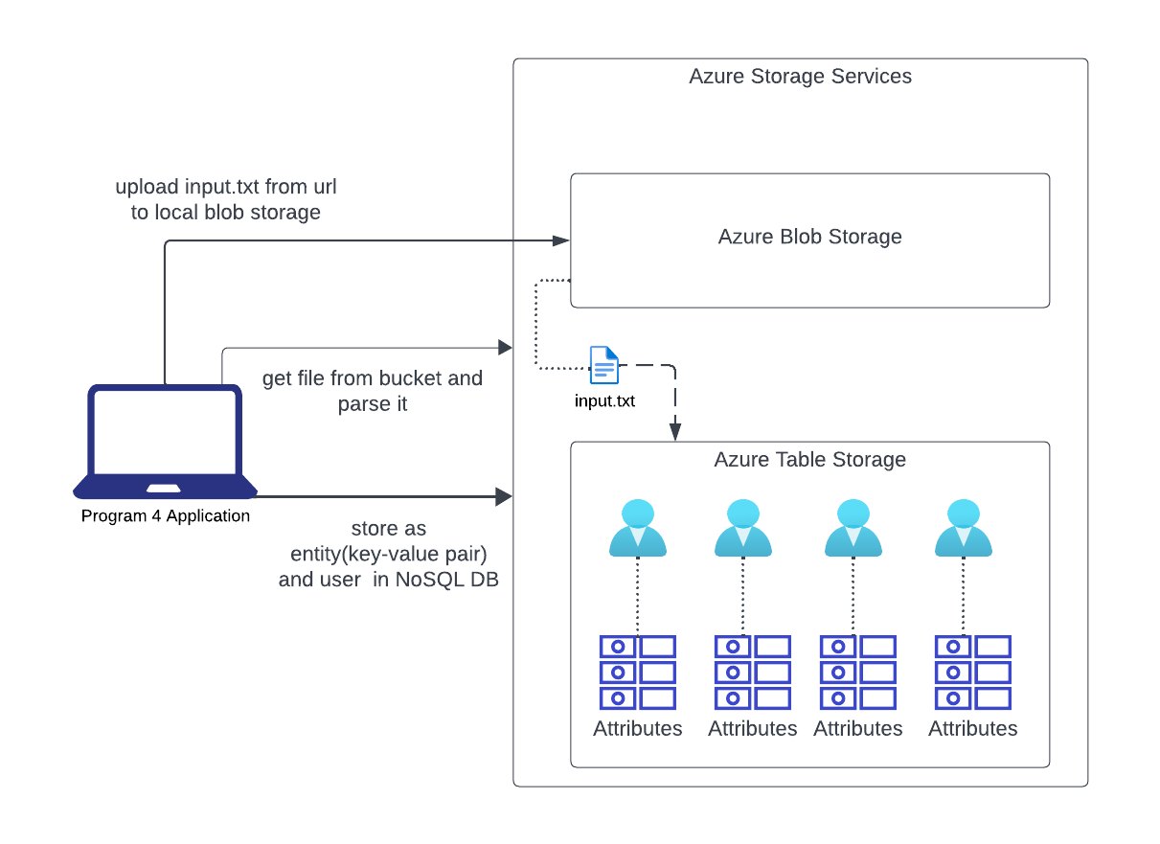

# Program

The framework used for this program was the ASP.NET MVC Core Web App on Visual Studio 2022. The languages used are JavaScript and HTML for frontend, and C# for server-side code. The services used were Azure blob storage and Azure tables.

The program consists of three main methods:

* **LoadData():** Loads the data from the URL into blob storage and then parses it NoSQL Azure table. One thing to note here is that load does not involve removing any existing attributes of the user. It can handle updates in the case where an existing attribute gets changed, but if an old attribute gets removed, the Load method will not account for that. It only adds and updates existing attributes. I have also checked with the professor regarding this and he said it is fine.
* **ClearData():** Loops through Azure table and deletes every entity. Note: the reason why I didn’t delete the table and re-create it was firstly because I was utilizing a single location for the table meaning that I had one table. I wasn’t creating a new table. Secondly because of the 409 issues I was running into. Since table deletion is an asynchronous operation on Azure, I was never notified of the exact time that the table would get deleted and when I would hit say a load after clear or I tried to create the table again, it would give a 409-issue saying the table is still being deleted. As a temporary fix, I decided to put the thread to sleep for some time and that seemed to work, however, this was a very bad solution because there is no sure way of calculating how long it would take for a table to actually get deleted. Therefore, to avoid the issue, I simply resorted to looping through the table and deleting entities which proved to be exponentially faster and would adapt based on the size of the table. Also realized that there could be cases where load/query can be pressed while clear is still happening therefore I made sure that the buttons were disabled until clear was finished.
* **Query(firstName, lastName)**: Simply searches the table based on the given parameters and returns the attributes back.

# Scaling with Load

Azure provides an “autoscale” option that scales automatically based on increased load that you can set up through the Azure portal.

There are primarily two types of scaling that this supports:

* Scale Up: Essentially increasing the resources(CPU, memory, storage) of a single instance. Ultimately this can be done automatically or manually where developers choose hardware and upgrades based on their needs or choose a certain level of upgrade like a specific pricing tier for the system.
* Scale-out: Adding more instances of the app to support increased HTTP traffic. Azure provides both manual and auto-scaling options for this as well. Manually, developers would set up a number of instances to use and scale out based on that. With autoscaling, developers can pre-define the maximum and minimum number of instances to scale out based on various metrics.

Regarding my website, it currently does not scale with load. This is because my app service plan is still on the free tier. The website is currently receiving CPU minutes on a shared VM instance and cannot scale out. Additionally, resources are limited with around 1 GB of storage, shared server resources, and a daily maximum allocation of 60 CPU minutes. If I wanted to scale with load, I would need to upgrade to a higher tier such as the Basic, Standard, or Premium tier offerings. That way I could enable autoscaling and accommodate the load appropriately.

# Monitoring

Azure provides several monitoring services for web applications.

* **Application Insights:** This is an extensible Application Performance Management (APM) service for developers. It monitors the application and detects anomalies such as poor performance, failures, and sends telemetry to the Azure portal. It is also used for logging, distributed tracing, and custom application metrics.
* **Azure Monitor:** Provides base-level infrastructure metrics and logs for most services in Azure.

* **Log Analytics:** This service helps correlate the usage and performance data collected by Application Insights with configuration and performance data across the Azure resources that support the app.

On top of these services, alerts can also be set which notify the developer if certain metrics fall.

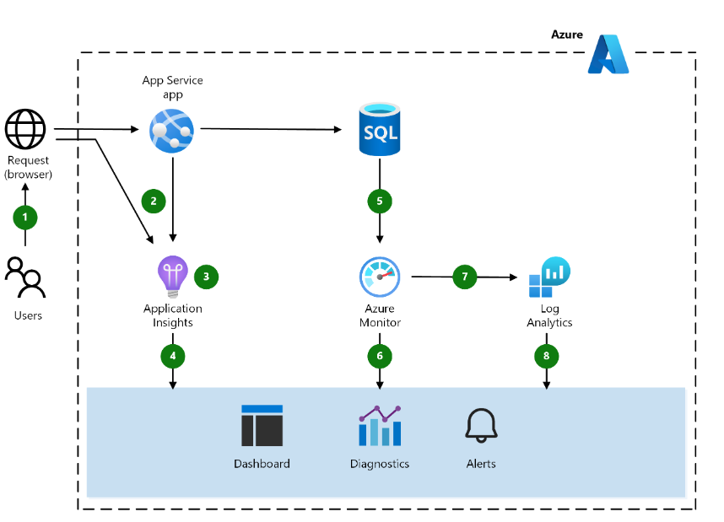

For my website, I could probably set up a few alerts on key metrics to ensure that I’m notified if they fall. Then I could integrate Azure monitor with my service and interact with the metrics by charting them on the Azure portal.

# SLA Estimate

**Azure Web Apps SLA**: 99.95%

**Azure Blob Storage**: 99.9%

**Azure Tables**: 99.9%

0.9995 * 0.999 * 0.999 = 0.9975

Therefore, the SLA for my website would be **99.75%**

An alternate scenario where say the Azure table storage is part of the same SLA as the blob storage

The SLA would be 0.9995 * 0.999 = 0.9985005 = 99.85%

(Note: while there doesn’t seem to be a specific SLA for Azure Table Storage, it's part of Azure storage which has an SLA of 99.9% so we could assume that both storage services could be part of the same SLA)

In this case, the SLA would be 99.85%.

# Works Cited

<https://learn.microsoft.com/en-us/azure/well-architected/service-guides/azure-app-service/reliability>

<https://learn.microsoft.com/en-us/azure/azure-monitor/autoscale/autoscale-overview#what-is-autoscale>

<https://learn.microsoft.com/en-us/azure/architecture/web-apps/guides/monitoring/app-monitoring>

<https://www.microsoft.com/licensing/docs/view/Service-Level-Agreements-SLA-for-Online-Services?lang=1>

<https://learn.microsoft.com/en-us/azure/app-service/overview-monitoring>